Software Requirements Specification
for
Library Management System

Muhammad Ghufran
Linus Dominic
Muhammad Ammar
Areesh Aslam
Mubeen Khalid
Feb 08, 2021
Version | Changes Made | Date
1.0 | N/A | N/A
1.2 | N/A | N/A
1.3 | N/A | N/A
1.4 | N/A | N/A

Table of Contents
1. Introduction
2. The General Description
3. Specific Requirements
4. Supporting Information
1. Introduction

1.1 Purpose

This document describes the software requirements for the Library Management System built for the Karachi Public Library(KPL).

1.2 Scope In

The KPL is requesting proposals to build a prototype of Library Management System.
The project is specifically designed for the use of librarians and library users. The product will work as a complete user interface for library management process and library usage from ordinary users. Library Management System can be used by any existing or new library to manage its books and book borrowing, insertion and monitoring. It is especially useful for any educational institute where modifications in the content can be done easily according to requirements.
The objectives of this development effort are:
- To provide existing users with a new environment.
- To provide an avenue for users to get their books in a more convenient way.
- To increase efficiency of Libra.
1.3 Scope Out

The following features will not be the part of this Project:

1.3 Definitions, Acronyms, and Abbreviations.

Asp.net -> platform independence
SQL-> Structured query Language
ER-> Entity Relationship
UML -> Unified Modeling Language
IDE-> Integrated Development Environment
SRS-> Software Requirement Specification
KPL->Karachi public library

1.4 References

• Situation Update – Chinese Railway Passenger Reservation System
http://www.cs.swt.edu/~donshafer/Marketing Update(1).html
• China 2000
http://www.china2thou.com
• Pressman, Roger S., Software Engineering: A Practitioner’s Approach, McGraw-Hill Companies, Inc., 1997.

1.5 Overview

Chapter 2 of the SRS is a brief description of the characteristics of the software to be built, its functions, its users, its constraints and its dependencies.

Chapter 3 is about specific requirements, such as functional requirements, external interface requirements, performance requirements, and also design constraints and quality characteristics.

Finally, chapter 4 includes all the supporting information, such as the Table of Contents, the Appendices, and the Index.

2. The General Description

This section describes the general factors that affect the product and its requirements. This section consists of five subsections that follow. This section does not state specific requirements. Each of the subsections makes those requirements easier to understand, it does not specify design or express specific requirements. Such detail is provided in section 3.

2.1 Product Perspective
The Automated Railway Reservation System diagram showing the overview of the system’s modules and the relationship of the system to external interfaces is presented in Figure 2.1.

Figure 2.1 Overview/Architecture Diagram of the ARRS

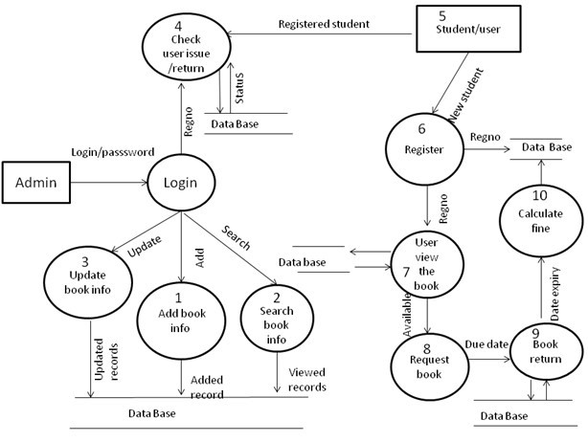

Functions of System Components:

Database:
• Stores data
• Creates reports
• Provides access to data
• Updates information

Server:
Ν/Α

External Interfaces:

Terminal
Ν/Α

Personal Computers
• Users (Any Person/Admin) may use personal computers to obtain a remote access to the sytem and perform according to their roles.

Cell Phones
Ν/Α

Computer Hardware and Peripheral Equipment to be used:
Ν/Α

2.2 Product Functions
This section provides a summary of the functions that the software will perform.
2.2.1 Function Relationships
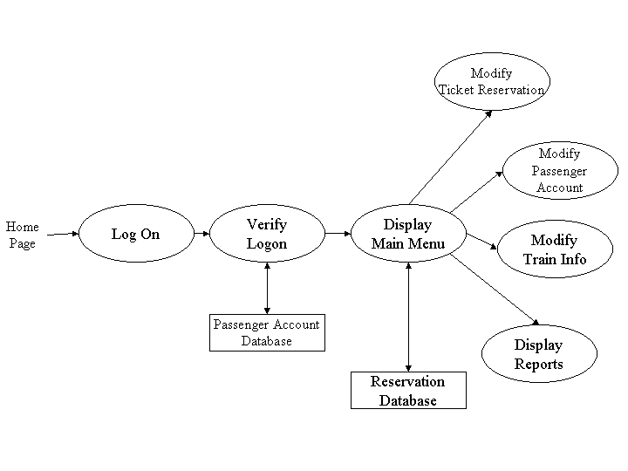
Figure 2.2 to 2.6 depict the relationships among the functions to be implemented by the system.
Figure 2.2 ARRS General Function Relationship/Higher Level Usecase Diagram
Book Registration

Registerd User

Book Laid

Suggestion

Issue Book/Return Book

2.2.2 Function Descriptions (Functional Requirement Listings)

2.2.2.1 Log In Function

Description: This function ensures that only authorized users gain access to the LMS databases. An authorized user is a user who has an account on the system. Users include students,teachers. The user must type a valid username and password to gain access.

2.2.2 Module 1: Book Registration

Description: This function allows the librarian to [Make | Drop | View | Update] a book.

2.2.3 Module 2: User Registration

Description: This function allows users to register in KPL to issue new book or to return their book. Users can also update their profile. Librarian/Admin can also add new users and also see the list of registerd users and can delete users.

2.2.4 Module 3: Book Laid

Description: This function allows admin to add book data which import from different country. Admin can delete books and update information of book.

2.2.5 Module 4: Issue Book/Return Book

Description: This function allows users to issue and return their books. Admin can update, delete the information of issued books

2.2.6 Module 5: Suggestion

Description: This function allows user to give suggestion about new books. Admin can [Make | Drop | View | Update] suggested ideas.

2.3 User Characteristics
The main users of the system will be the students, teachers and the KPL administration/Librarian that access the reports generated by the system. The users are not required to have knowledge in the computer field. The graphical interface provides an easy way of using the LMS system with minimum of training.

  - General Constraints
The constraints for the project are
N/A.

2.5 Assumptions and Dependencies or Business Logic
The assumptions for the project are:
- System will user friendly
• System will active 24 hours in a day
- User will search the books by its name
- System will complete on time.
- User may access from any computer that has internet browsing capabilities and an internet connection

<ADD OOAD REPORT DIAGRAMS HERE>

3. Specific Requirements

This section of the SRS contains design requirements for the Automated Railway Reservation System.

3.1 Functional Requirements

3.1.1 Log In Function

- Description: This function ensures that only authorized users gain access to the Reservation databases. An authorized user is a user who has an account on the system. Users include passengers, train officials, and CRM ministry officials. The user must type a valid username and password to gain access.

- Usage Scenario/ Use case Description/ Specification:

Description | Allows access to online LMS
Inputs | Username, password
Source | - User inputs username and password  - Press Login Button

Alternate case
Outputs | Successful login; unsuccessful login
Destination | None
Precondition | Authorized User
Post Condition | No change to user Accounts Database
Side Effects | Failures and successful logins are sent to Registered Database

- Detailed Use case Diagram for Login: optional
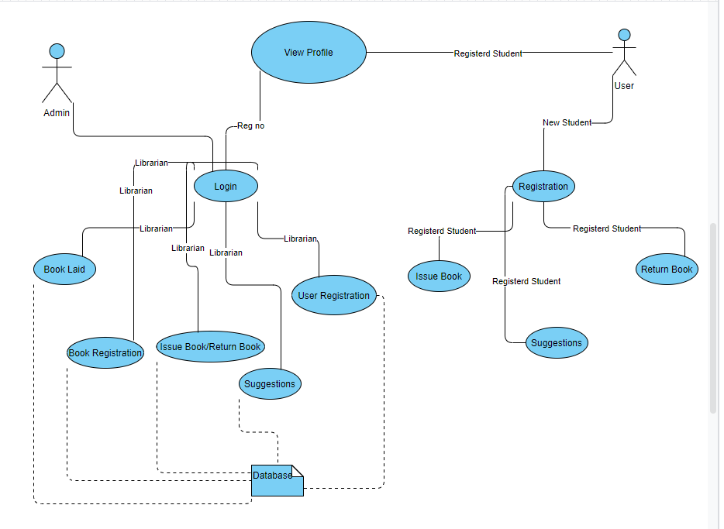
- Use case Realization for Login: optional
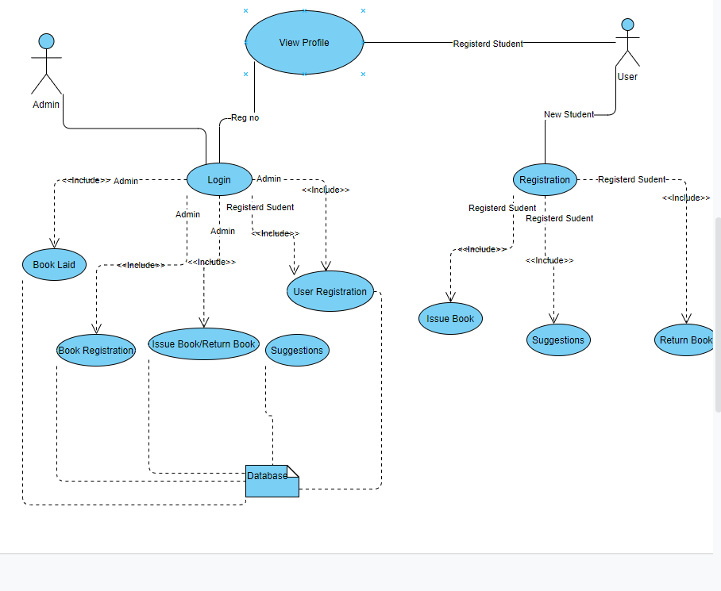

- Flow of Event or Data Flow Diagram for Login: optional

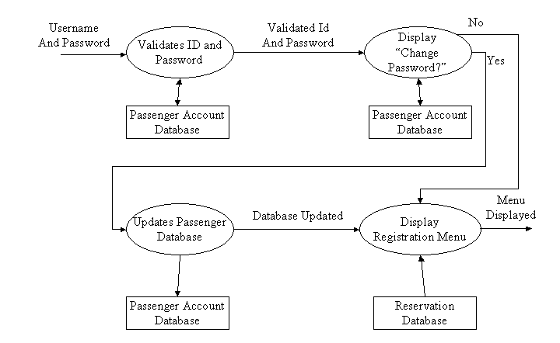

- Sequence Diagram for Login: optional
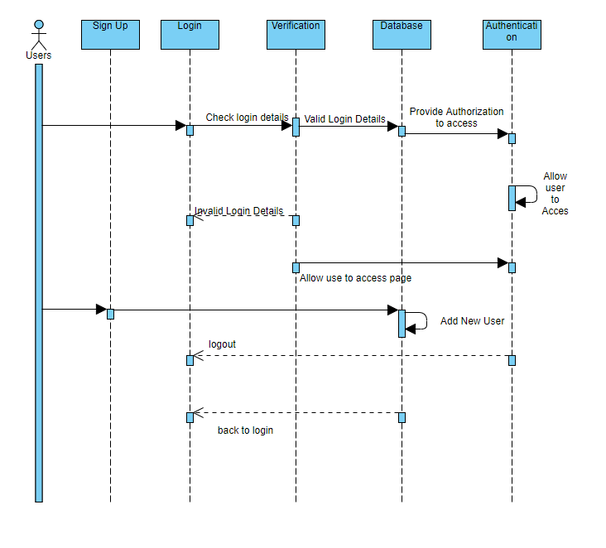
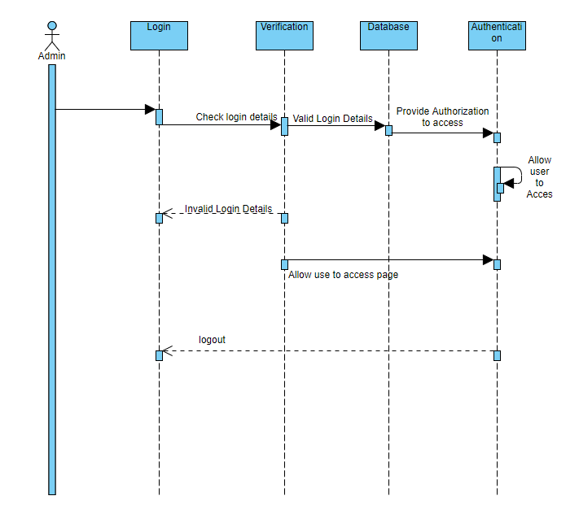

- Collaboration Diagram for Login: optional
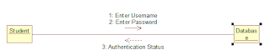

- Activity Diagram for Login: optional
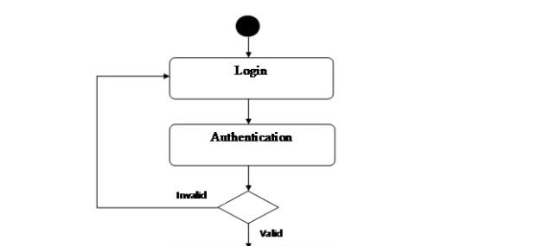

- Class Diagram for Login: optional
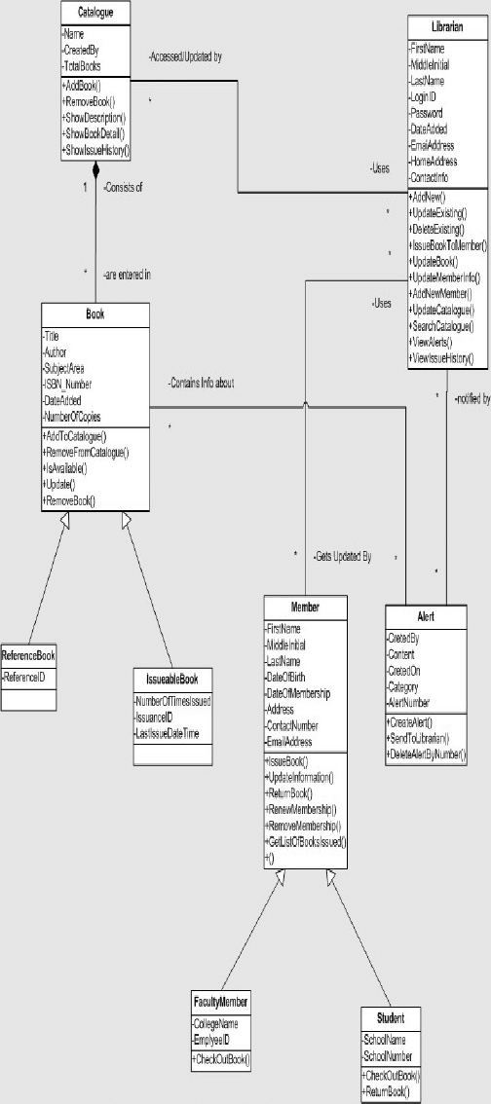

- State Chart Diagram for Login: optional

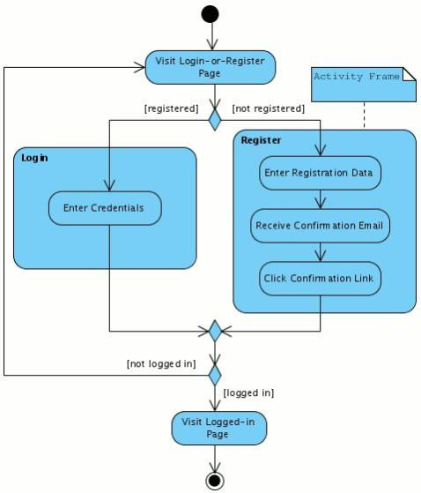

    - Module 1 complete CRUD Book Registration

- Description: This function allows the user to [make | drop | view | update] a reservation for a particular train on a particular date for a certain number of tickets. If the user does not already have a reservation, then a new reservation is created. If the user already has a previous reservation, a new reservation is added to the list of current reservations, and the passenger account balance gets updated.

- Usage Scenario/ Use case Description/ Specification:

Description | [ make | drop | view | update] a Book Registration
Inputs | Authar,title,date
Source | - Admin inputs Authar name,Book Tiltle and category and date  - Press Button …

Alternate Case
Outputs | Added | Deleted | Viewed | Modified Books
Destination | Computer screen  LMS database
Precondition | N/A
Post Condition | N/A
Side Effects | N/A

- Use case Diagram:
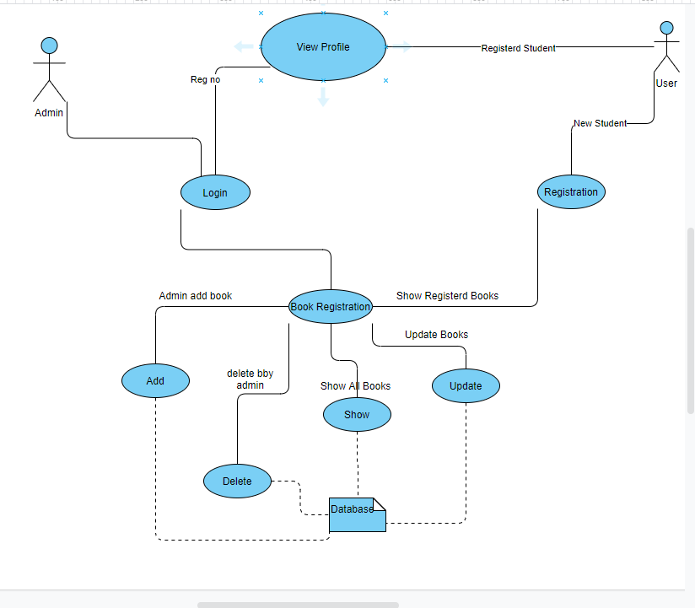

- Use case Realization:
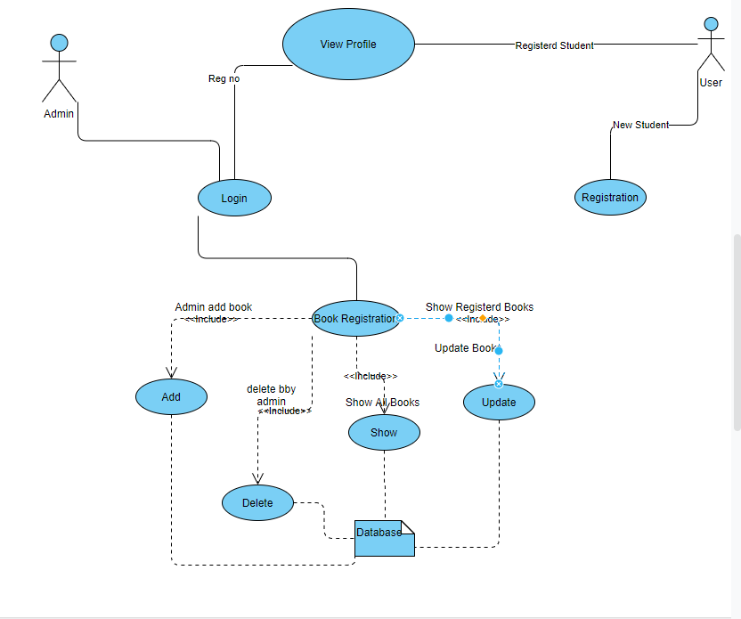

- Flow of Event or Data Flow Diagram:
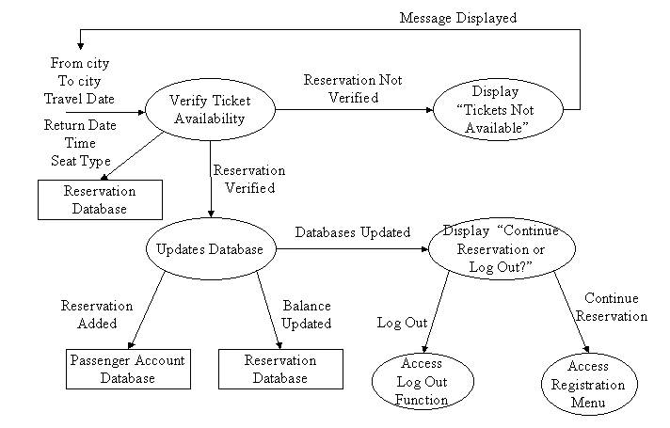

- Sequence Diagram:
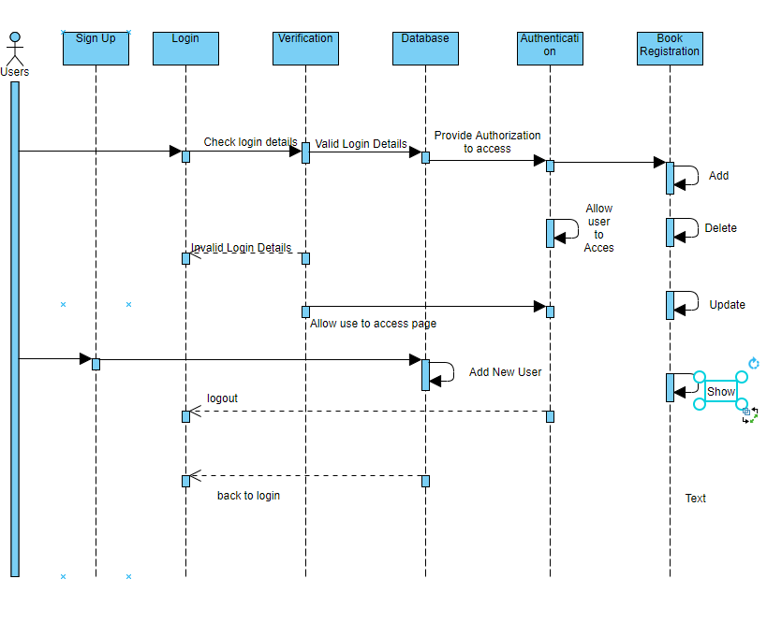

- Collaboration Diagram:
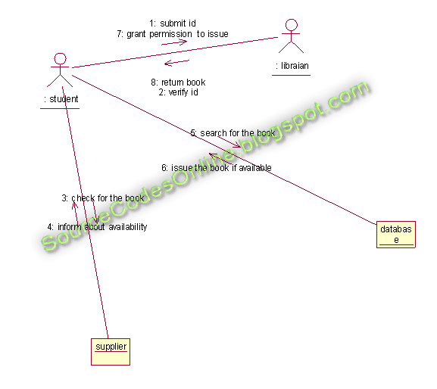

- Activity Diagram:
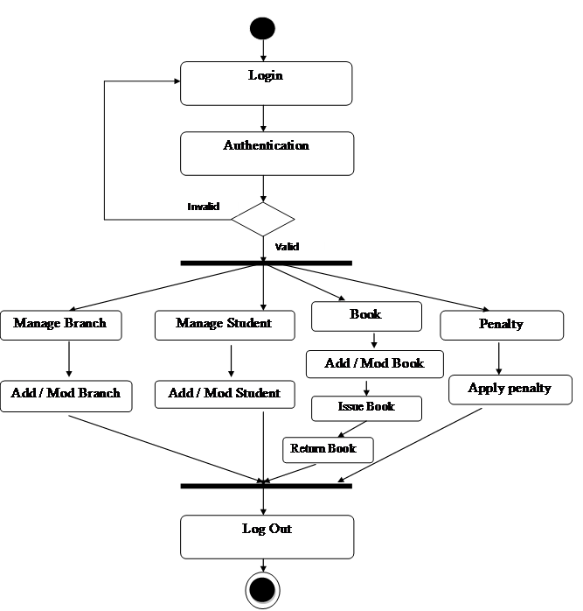

- Class Diagram:

- State Chart Diagram:

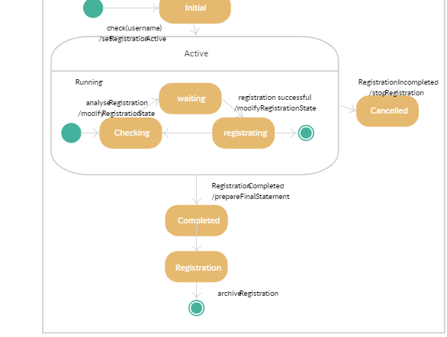

    - Module 3 complete CRUD User Registration

Usage Scenario/ Use case Description

Description | [ make | drop | view | update] a User Registration
Inputs | Authar,title,date
Source | - Admin inputs Authar name,Book Tiltle and category and date  - Press Button …

Alternate Case
Outputs | Added | Deleted | Viewed | Modified Books
Destination | Computer screen  LMS database
Precondition | N/A
Post Condition | N/A
Side Effects | N/A

- Use Case Digram
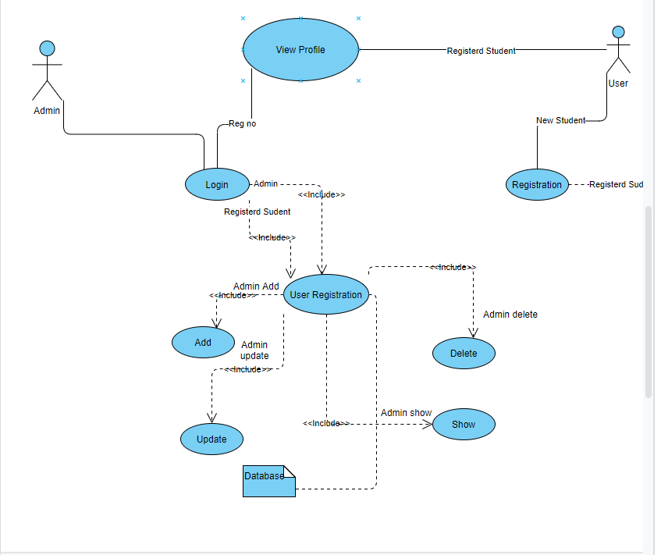
- Use Case Realization
- Sequence Digram
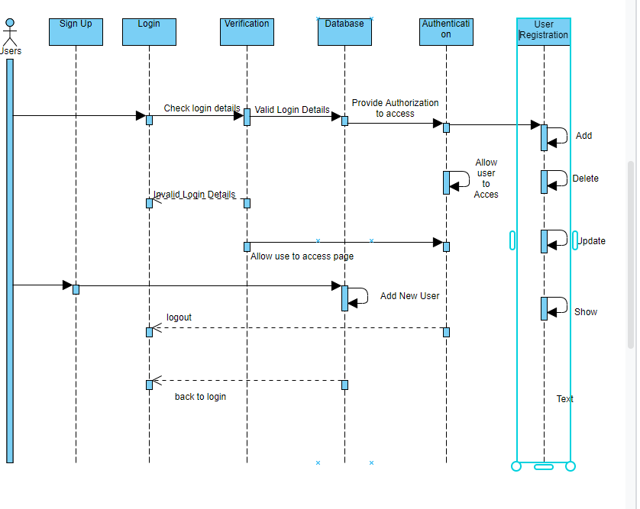
- State Chart Digram
- Collaboration Digram
- Class Digram

    - Module 4 complete CRUD Issue And Return Book
- Use Case Digram
- Use Case Realization
- Sequence Digram
- Collaboration Digram
- Class Digram
    - Module 5 complete CRUD Book Lend

Usage Scenario/ Use case Description
Description | [ make | drop | view | update] a Book Lend
Inputs | Authar,title,date
Source | - Admin inputs Authar name,Book Tiltle and category and date  - Press Button …

Alternate Case
Outputs | Added | Deleted | Viewed | Modified Books
Destination | Computer screen  LMS database
Precondition | N/A
Post Condition | N/A
Side Effects | N/A

- Use Case Digram
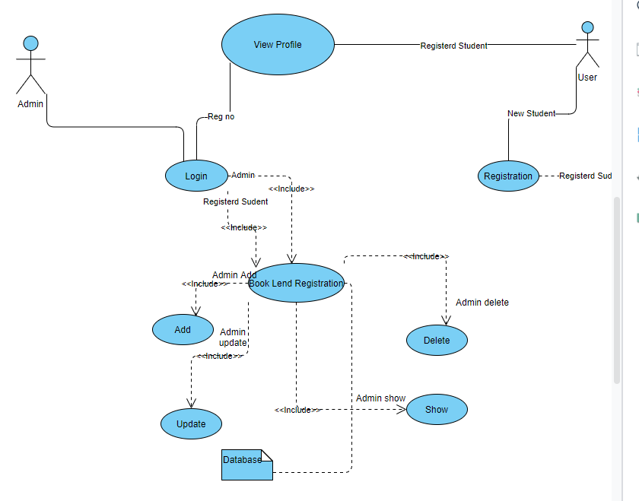
b) State Chart Digram
- Use Case Realization
d) Collaboration Digram
- Class Digram
f) Sequence Digram
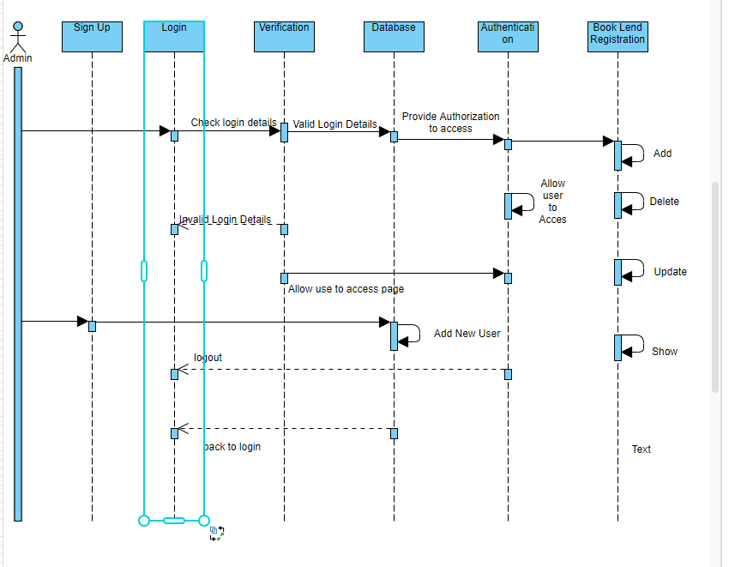

3.2. External Interface Requirements
3.2.1 User Interfaces
The user interfaces are divided into two major components. One part includes the user accessing the system using web application. The other portion involves accessing the system through a remote site or at a particular location specifically designed to access the system. For instance, the clerks and the Kpl access the Library system.

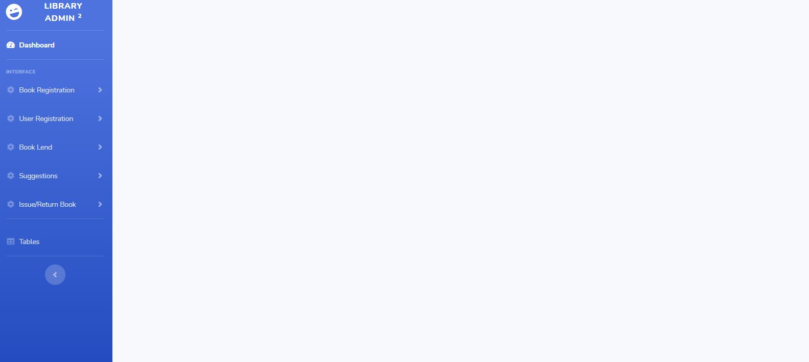

Selecting one of these functions will take the user to a different user interface. For instance, choosing Book Registration will display the following web page. The title of this page is consistent with the function selected,

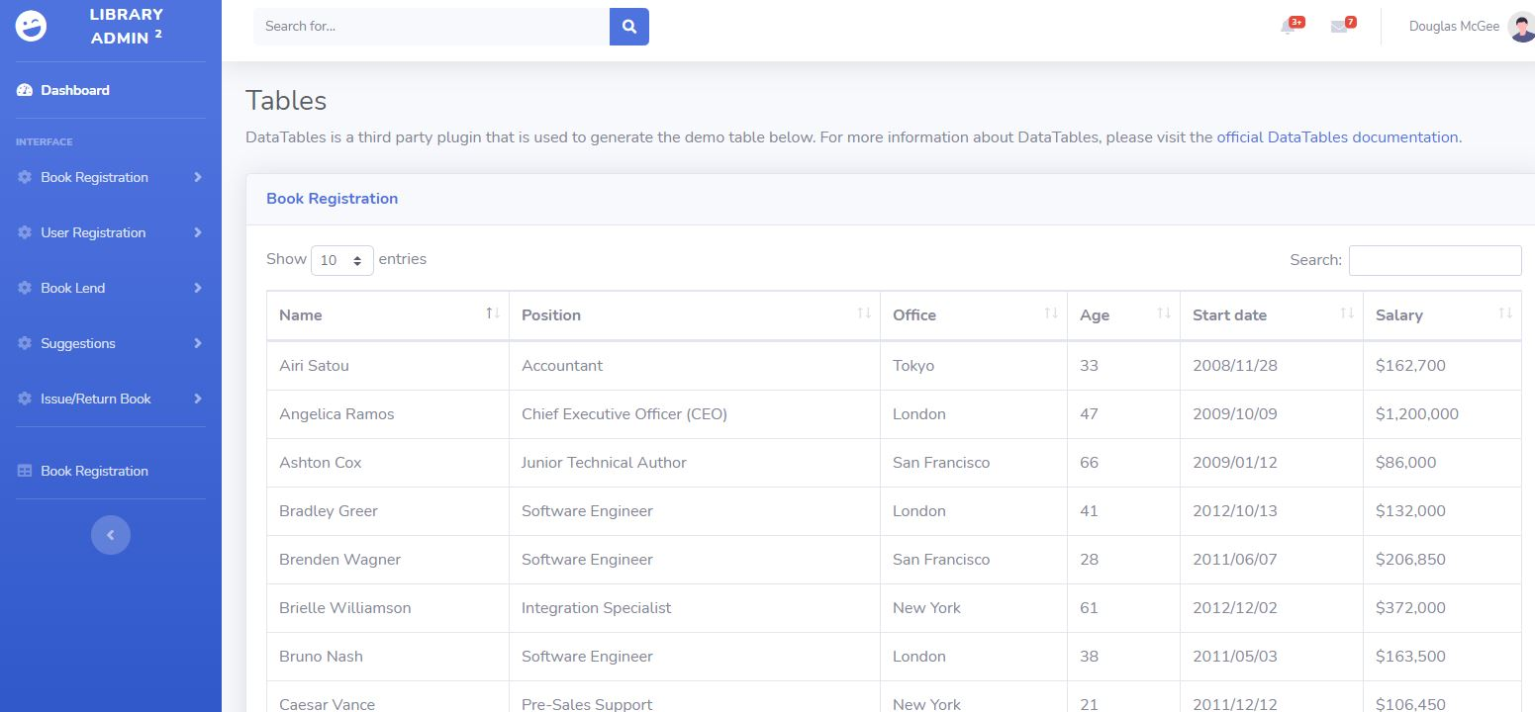

Selecting one of these functions will take the user to a different user interface. For instance, choosing User Registration will display the following web page. The title of this page is consistent with the function selected,

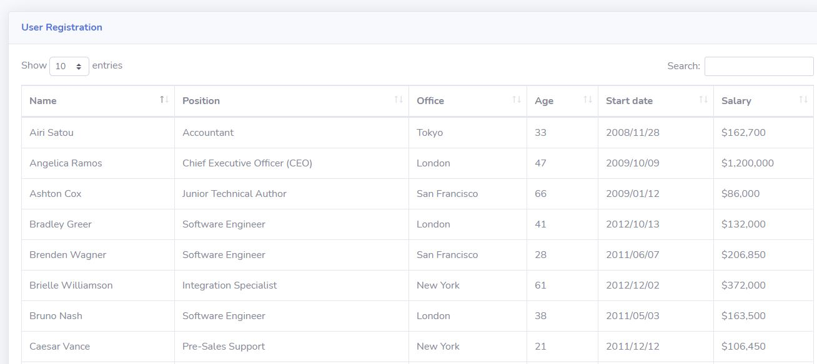

Selecting one of these functions will take the user to a different user interface. For instance, choosing Book Lend will display the following web page. The title of this page is consistent with the function selected,

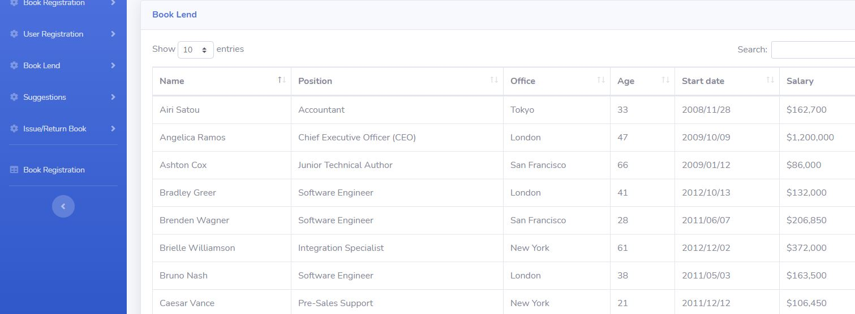

3.2.2 Hardware Interfaces
N/A.

3.2.3 Software Interfaces
Sql server DBMS will be used to manage the database and any changes made to it. Furthermore, the DBMS will make regular backups of the database and generate reports regularly so that they can be accessed by the KPL. Furthermore, the HTML pages must be implemented such that they can be displayed on two common browsers: Google Chrome and Internet Explorer.

Information about the products used for the ARRS:

(1) Name: Sql Server
(2) Mnemonic: Ms sql
(3) Version Number: ?
(4) Source: sql server

(1) Name: windows
(2) Mnemonic: windows
(3) Version Number: 10
(4) Source: ?

(1) Name: Internet Explorer
(2) Mnemonic: IE
(3) Version Number: 5.00
(4) Source: Microsoft

(1) Name: Chrome
(2) Mnemonic: Chrome
(3) Version Number: 1.3.14

3.3 Performance Requirements
The following sections list the performance requirements for the system.

3.3.1 User Requirements

User Requirements | Description of Requirement For Design Environment
Location(s) and Number(s) of Users | Guangzhou, Nanjing, Shanghai
Expected Growth in Number of Users
After 1 Year | 50%
After 2 Years | TBD
After 3 Years | TBD
User Expectation
Interactivity | User expect that it provides a very easy to use graphical user interface
Reliability | For some applications, reliability must be 100% during the application session
Adaptability | Network must adapt to user additions, deletions and changes
Security | Encryption software would be used for Credit Card transactions
Cost / Funding | Less than $250K

3.3.2 Application Requirements

Since no specified service is indicated, then we have listed the applications as best – efforts. This may change as we learn more about the application.

The communication package is determined to be bursty in nature, with small data sizes and frequent transmissions. We can consider this application to be interactive-burst, while the database transaction-processing application is described by the CRM as transferring large amounts of data (initial estimates are 1 MB/transaction), we have listed this application as interactive-bulk.

Categorizing  Applications | Best-Efforts | Application  Locations
Communication | 100 Kb/s | Guangzhou and Nanjing
Database Access | 400 Kb/s | All Locations
Database Transaction processing | 1.5 Mb/s | All Locations

3.3.3 Host Requirements

 | Type of Host or  Equipment | Numbers and  Locations
Host A | PC | Guangzhou (10), Nanjing(7), Shanghai(10)
Host B | Database Server | Shanghai
Host C | Application Server | Nanjing

3.4.1 Standards Compliance
There are no design constraints that can be imposed by other standards limitations.

3.4.2 Software Limitations
• must be able to run Internet Explorer or Netscape Communicator web browsers to access the system.
• must have cell-phone web based capability to access the system from a mobile phone.

3.4.3 Hardware Limitations
• Input/Output: One or two-button mouse, keyboard, cell-phone, or touch screen required.
• Network card required at thin-client terminals to make communication with server possible.

3.5 Quality Characteristics
There are a number of quality characteristics that apply to the ARRS software system.

3.5.1 Portability
The ARRS system will be developed using HTML and Java so that it can be accessed from any type of system using just a regular web browser. It will also be available to users that have web access on their cellular phones. The system will be tested on all types of hardware before being released to ensure that is it compliant with this requirement.

3.5.2 Reliability

The system should be capable of processing a given number of reservations within a give time frame with no errors and the system should be available and operational all the time. During the development of the prototype for the 3 cities, the system will be tested in its actual environment to ensure that it can handle the load of reservations that occur during a regular workday.

3.5.3 Usability
The ARRS system will be developed so that it is an easy to use system that requires the least amount of user input possible. Every input will be validated. The user should only have general computer use knowledge. Error messages will be displayed if the user enters an invalid value or tries to access a function without the required permissions. An easy and well-structured user manual will be provided to the CRM and the system will include descriptive help for all operations allowed.
3.5.4 Correctness
The ARRS system will be considered correct when the CRM approves the prototype presented and agrees that all the functions they require are implemented as stated in the Software Requirements Specification.
3.5.5 Flexibility
The ARRS system should be developed in such a way that it is easily customizable. If new functions are required by CRM, there will be little effort required to update the system to support new cities or new transactions.
3.5.6 Security

The ARRS system should not compromise the customer information at any time. The user information will never be sold to other parties and will be kept secure at all times. Users will be authenticated to ensure that no unauthorized users gain access to private information.

3.5.7 Maintainability
The ARRS source code will be kept well structure and documented so that it is easier to maintain and extend the system. All changes to the system shall be documented.

3.6 Other Requirements
Certain requirements may, due to the nature of the software, the user organization, etc., be placed in separate categories such as those below.

3.6.1 Data Base
N/A

3.6.2 Operations
There is no operations required

3.6.3 Site Adaptation Requirements
There are no site adaptation requirements for this project.

4. Supporting Information.
There is no supporting information required for this project.

